**Generating CSR files in Azure VM**

**Step -1 –** Login to the VM in which we need to generate CSR Certificate

**Step -2** – Navigate to IIS (Internet Information Service)

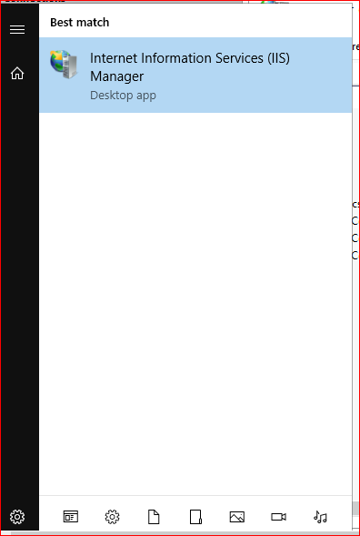

**Step -3 –** In that click on “**Server Certificates Icon”**

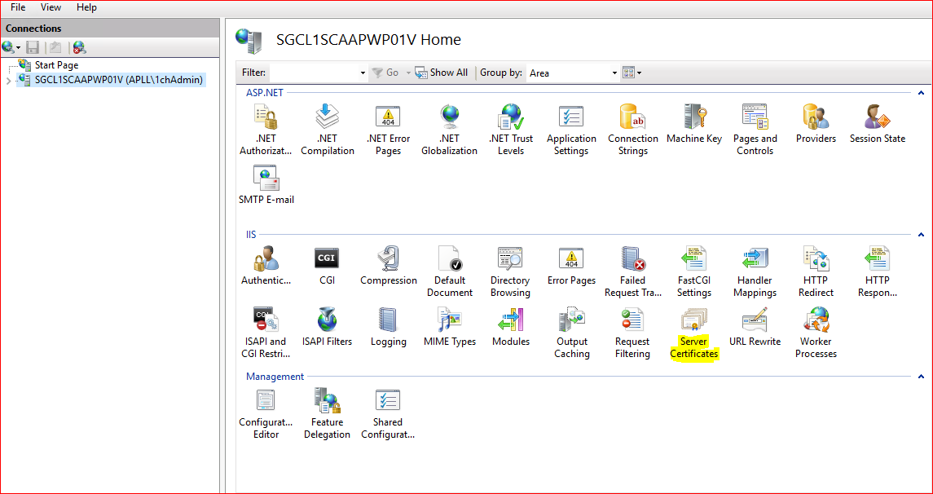

**Step -4 –** Which pops out a menu and there in the left corner click on **“Create Certificate Request”**

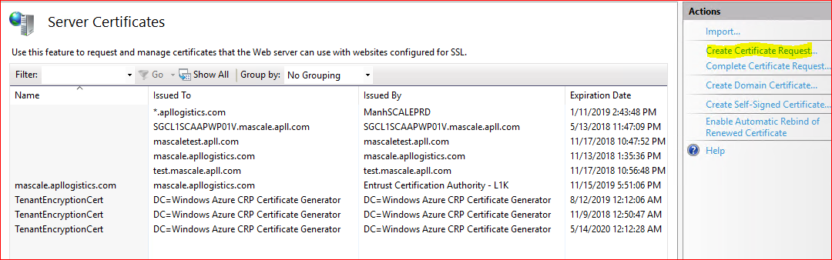

**Step -5 –** Fill the required details provided by the customer**.** And click on Next.

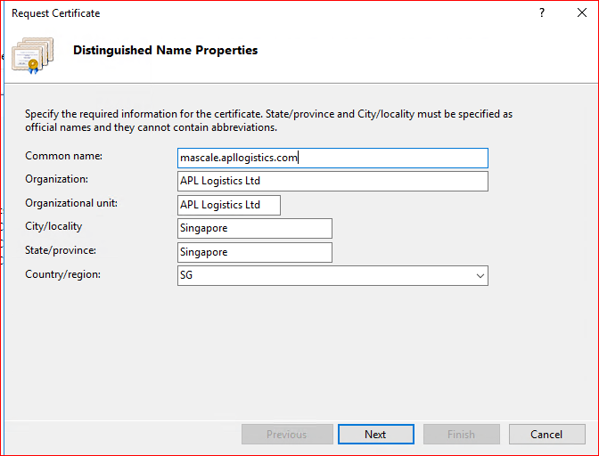

**Step -6 – Click on next**

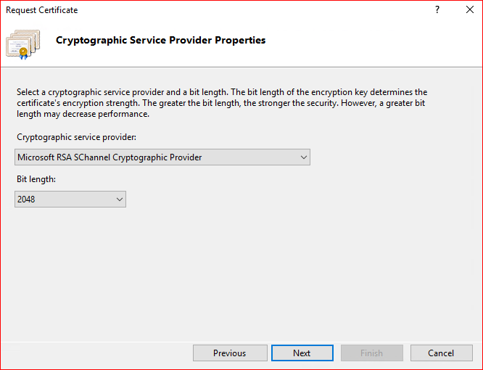

**Step -7 –Specify the folder to save and click on finish.**

